

Applied Computing
Group: 3

Pharos Parcel Application
Team Report

Contents

Introduction 3
Design Problem 3
Design Strategy 3
Platform 3
Alternative Platforms 4
Risk Assessment 5
Application 5
Use Case Analysis 5
User Interface Analysis 5
User Centred Design 6
Preliminary Results 6
Subsequent Results 6
Prototyping 7
Problems 8
Testing 8
Test Strategy 8
Test Plan 9
Extension & Future Implementation 9
Conclusion 9
Appendix 11
Risk Assessment 12
Informed Consent Form - Participants 14
Questionnaire 15
Test Data 17
Bibliography 19

Pharos Parcel

Introduction
Pharos Parcel is a small parcel courier business, based in the Scottish town of Perth. It primarily deals with domestic and export distribution to commercial and non-commercial customers, using established courier firms such as UPS and Yodel. The customer base consists of those that which the larger firms generally fail to pursue.

Pharos Parcel already has a worldwide web presence, yet is looking to keep abreast of the latest technological developments. Such a development is an application for a mobile phone, which would improve accessibility to Pharos Parcel’s services and allow the customer base to expand in an increasingly crowded market.

The application that we have chosen to develop is a version of the existing Pharos Parcel website, exclusively for mobile devices.

Design Problem
We were presented with the problem of choosing which platform to implement the application for, due to limited resources and budget constraints:
- Android (Google)
- iPhone (Apple)

Having conducted some elementary background research, we decided to produce an application suitable for the Android platform.

Design Strategy

Platform
The platform chosen to produce a prototype for is Android, particularly version 2.1.

The main reasons being that up until March 2011, Android was an open platform, where Google allowed free developmental use and waived licensing restrictions. Version 3.0 from March 2011 became restricted to only original equipment manufacturers and trusted developers, though apparently version 4.0 will revert to open status when it is released.

The Android platform was also seen to have a wider user base with around a half-million new activations per day in 2011.

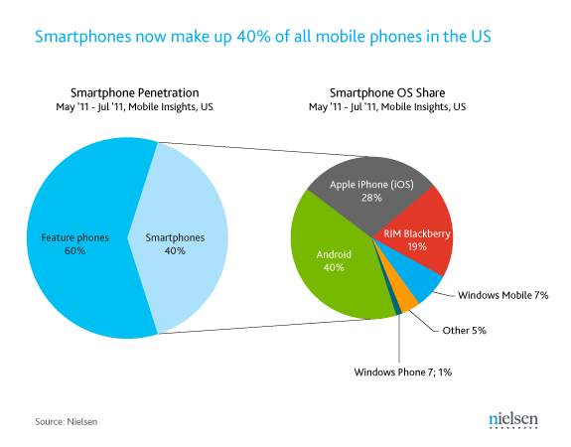
Figure 1: Smartphone market penetration May – July, 2011. © Nielsen.

Alternative Platforms

iPhone
We looked at implementing an application for the largest competitor platform, Apple’s iPhone.
- We noted that competitor products are stealing market share from Apple.
- We also noted that the iPhone is restricted to software approved by Apple.

Due to these points we decided to remove the Apple iPhone from the investigation.

Blackberry
Similarly, Research in Motion (RIM) market the Blackberry. Whilst this platform has a smaller market share, it would appear that in the near future, the Blackberry smart phone will be compatible with Android applications.

This preliminary research would suggest that the Android platform will continue to grow and thus be the platform of choice.

Risk Assessment
We conducted an assessment to prioritise the risks. We consider that we have calculated correctly for all risks and have an appropriate action plan.

The Risk Assessment can be found in the Appendix.

Application
The proposed application is anticipated to be a streamlined version of the existing website application: http://www.pharosparcel.com/

The general layout will be similar but for reasons of screen space, will omit unnecessary pictures and logos. Functions that currently co-exist on the website, such as quotation and tracking, will be split to different tabs on the smart phone.

Use Case Analysis
We conducted a Use Case analysis to logically track the steps the customer would follow in order to use the application.

The Use Case Analysis can be viewed in the separate document.

User Interface Analysis

Application control
The application will be controlled by virtual buttons and tabs overlaid upon the smart phone’s touch screen. Selection of a desired option simply requires the user to touch the appropriate button within the screen area.

Display
The screen resolution is expected to be 320 x 240 pixels, which equates to 4:3 aspect ratio. The Android platform allows the display resolution to be scaled to suit the host device.

Colours
The colour scheme has been designed to reflect the current colour scheme of www.PharosParcel.com.

We understand that the original website’s colour scheme should be more aligned to red than orange, but that there was some degree of difficulty in achieving the correct colour. For the reason of presenting a consistent interface, we chose to retain the perceived orange colour scheme.

Icons
The display, being of a tab layout, must allow intuitive use and easy recognition of functions. For this reason, the icons will reflect their function as shown in the figure below. For example, the Packages icon, will allow the customer to select services pertaining to the parcel, such as quotation and sending parcel.

Final design screenshots are displayed in the Appendix.

User Centred Design
We decided from the outset that our design must be user-centred. We considered various methodologies and chose an Agile type approach. Whilst not true Agile, we were careful to ensure that users would be placed at the heart of the design.

We would design a low technology prototype, get volunteers to test the prototype, evaluate the results, and endeavour to adapt the initial design to incorporate the changes that were suggested by the users. We would then retest and re-evaluate the results.

We considered various user demographics and that due to time and procedural constraints, it would be quicker to internalise the testing rather than employing external user groups, which would potentially delay ethical approval. We attained the necessary approval within a short timeframe.

We decided that our demographic would be a group of users, numbering at least ten, although more would be preferable. The users would be recruited from the lower years within the University of Dundee’s School of Computing. The basic premise being that the users would already be accustomed to smartphone usage with their multitude of applications or “apps”, as they have become known, and thus be in a position to suggest improvements and alterations to the prototype interface.

We managed to engage a user group of fourteen persons, of both genders. Ages ranged from seventeen to thirty years. They were tasked with answering a questionnaire, having seen a demonstration of the low technology prototype.

Preliminary Results
We found that the user demonstration was generally well received and the feedback is summarised below:

- The analysis of the data for the demonstration suggested that the general layout and navigation was received well by the participants.

- The majority of the participants thought that the proposed application had good functionality.

- The majority of the participants thought that it would be a useful application that they would use.

With this data, we felt that we were following the correct design path and were justified in doing so.

Subsequent Results

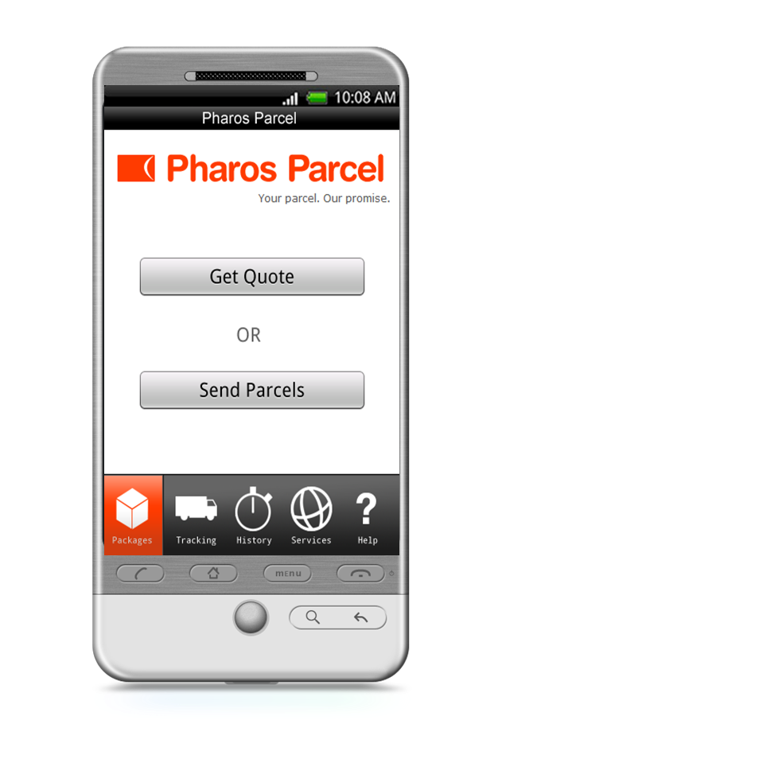
Figure 2: Initial prototype displaying the general layout of the proposed application.

Prototyping
Prototyping consisted of two stages.

The first stage was a low technology prototype; basically a Microsoft PowerPoint Presentation to present to the client, in order to elicit feedback. The display screens shown upon the smart phone in the first presentation (Fig 2) were achieved with artistic licence; there was no working prototype at this point.

The second stage was to provide a working prototype. This was achieved by using Android Software Development Kit (SDK), in conjunction with Eclipse Integrated Development Environment (IDE). The created software was downloaded to two HTC smartphones running Android Operating System. This was to be presented to the client towards the end of the project.

Problems
We encountered problems with downloading the Android software to the development computers; it took a long time. The instructions for Android suggested that the Eclipse Indigo Classic IDE be used, but we learned through trial and error that Eclipse Indigo for Java Developers was the correct version to use.

The smartphones were the same make, but one was slightly older than the other. We discovered that there were incompatibilities between the two phones and the Eclipse SDK. This was resolved by seeking a version of Eclipse that worked with both phones.

Testing

Test Strategy
The test method, or strategy, employed in testing a program, has a bearing in the test results. There are two testing strategies, namely “Top Down” and “Bottom Up”.

Top Down Testing tests each refinement level in a logical sequence, but relies upon the program being complete. For the benefit of this project, Top Down Testing will be employed.

Top Down Testing
This method starts with the main function and progresses down through the various refinement levels into the low level functions. Each function has to be tested as each subsequent level is added. This allows a logical progression through the program.

Test Techniques
There are two methods of program testing, White Box testing, and Black Box testing. They are not alternatives to each other, but actually compliment each other.

White Box Testing
This is started early on in program development and tests the complete program, following all possible logical paths that the program has. The aim of this method is to ensure that all statements within a module have been executed at least once. All test conditions have to be tested on the True and False states, all loops and their boundaries have to be tested. All data structures have to be checked for validity.

Black Box Testing
This method tests the program against the specification to ensure that it meets the original requirements. This technique is used late on in programme development, and tests each module as a closed box where the structure is hidden from the tester.

Test Plan
A suitable test plan would be to test individual inputs expected within the program, as well as inputs that would not be expected in the program. The inputs should test the boundary conditions too.

All the screens will be thoroughly tested. The application has to be absolutely correct, otherwise there will be disappointment.

The test technique that will initially be employed in this project will be white box as this will allow the application to be tested as it is created and follows the various logical paths through the program. Later, black box testing will be used to ensure that the application meets the requirements specification.

The test data can be found in the Appendix, Table 1: Test Data.

Refactoring
The application code was altered a few times, but generally tidied up as it was produced.

Extension & Future Implementation
We considered adding a feature that would allow the customer to take photographs of the parcel, measuring the length, breadth and height of the parcel as it went. However, research suggested that the feature would be awkward to implement, due to inaccuracies in the measuring application, and the fact that the parcel would have to be aligned extremely accurately to the phone’s camera.

Due to these inconsistencies, we decided not to implement such a feature at this time, but remain mindful to future integration.

Conclusion
We considered that this project was useful in providing us with a real client, Pharos Parcel, who had specific requirements and constraints that had to be met. We found that the client had a general idea of what they wanted and provided necessary feedback as and when required, which contributed greatly to achieving the desired result within the three week development process.

We think that the team in general worked well, even though there were conflicts of interest. However, these were largely brushed aside and the necessary work produced to schedule.

Some of the initial ideas proved to be overly ambitious and too time consuming to implement within the short timeframe, though they may yet be used in future implementations.

Appendix

Risk Assessment

The following table indicates which of the risks are in danger of serious disruption to the project. Only the top five are highlighted, as the remainder were deemed to pose a negligible risk.
Risk | Likelihood of Loss | Loss | Severity | Priority
Failure to get ethics approval in time for user testing | 7 | 8 | 56 | 2
Failure to understand the Android development process. | 6 | 10 | 60 | 1
Unavailability of team members due to unforeseen circumstances. | 4 | 7 | 28 | 4
Development computers fail. | 2 | 2 | 4 | 6
Communication failure. | 4 | 4 | 16 | 5
Underestimating project scheduling. | 7 | 7 | 49 | 3

Action Plan

- If certain key features have not been developed by Tuesday 21st September due to lack of knowledge or understanding of the android development process, we expect to develop a similar prototype in html/css as a mobile web application.
- We will apply for ethics approval as soon as possible and we have devised a user testing schedule which should not require any special requirements.
- Maintain an updated Gantt chart and have regular group meetings. Look out for any task that is overdue or anyone who is overloaded and the possible reasons and solutions for this.
- Ensure that all team members back up all of their work to a version control system which every other team member has access to. Keep in contact with all team members so any issues related to this can be solved ASAP.
- Daily Scrums.
- We have access to a number of back up computers and all work will be backed up to more than one system including a network share.

Team Charter

This document hereby certifies that the following personnel:

Daniel Herron 07809879771 D.Herron@ dundee.ac.uk
Ben Gorman 07825091207 B.Gorman@dundee.ac.uk
Emma Coutts 07791149027 E.R.Coutts@dundee.ac.uk
Calum Morrison 07856634768 C.K.Morrison@dundee.ac.uk
Terry Huang 07741711870 T.Huang@dundee.ac.uk

Contactable as above, are inclusive to the team of:

“Group 3”

- We agree to conduct ourselves in a professional manner, and not cause disruption to critical processes.
- We agree to uphold professional standards and apply them to all processes.
- We agree to endeavour to be available and punctual for team meetings.
- We agree to submissions being delivered in timely fashion.
- We agree to provide appropriate assistance and leadership skills as and when required.
- We agree to share knowledge where possible.
- We agree to inform our team members of possible conflictions, regarding meetings.

Signatures: Date: 12th September 2011

C.K.Morrison E.R.Coutts B.Gorman

D.Herron T.Huang

Functional requirements

1. Packages
  - Quote
1.1.1 Query Quote
The customer shall be able to query a quote based on the destination and dimensions of the package.
1.1.2 View Quotes
The customer shall be able to view a list of quote based on the services that Pharos Packages currently offer.
1.1.3 Send parcel from quote
The customer shall be able to go straight from send parcel from the quote page

  - Send parcels
1.2.1 Personal Details
The customer shall be able to enter their personal details (Title, forename, surname, email and phone number).
1.2.2 Collection address
The customer shall be able to enter the collection address (company address, address, town, post code).
1.2.3 Email Printable label
The customer shall receive an e mail with the printable parcel label.
1.2.4 Download printable label
The customer may be given the option to download the printable label as a PDF.

- Tracking
2.1 Barcode
2.1.1 Scan Barcode
The customer shall be given the option to scan the parcel barcode to track their parcel.
2.1.2 Barcode down load prompt
The customer shall be given a prompt to download a barcode scanner if they do not currently have on installed on their phone.
2.2 Speech
2.2.1 Voice search
The customer shall be given the option to speak the parcel tracking number to track their parcel.
2.2.2 Text to Speech download prompt
The customer may be given a prompt to download ‘text to Speech software’ if they do not currently have on installed on their phone.
2.2.3 Incorrect Entry
The device shall prompt the user to re-enter their tracking details if initial entry is incorrect.
2.3 Manual Entry
2.3.1 Find Parcel
The customer shall be able to type in their tracking number in order to track their parcel.
2.3.2 Incorrect Entry
The device shall prompt the user to re-enter their tracking details if initial entry is incorrect.
2.4 Recently Tracked
2.4.1 Recently Tracked List
The customer shall be able to select from the 10 most recent parcels they have tracked.
2.4.2 Delete Recently Tracked Item
The customer may be able to delete an item from the Tracking History.
2.4.3 Delete Recently Tracked Items
The customer may be able to delete multiple items from the Tracking History.

2.5 Notifications
2.5.1 Tracking Push Notifications
The customer may enable notifications that will inform them of their parcels’ progress in transit (such as “Out for Delivery”, “Processed at Local Hub”).

3. History
3.1 Transactions
3.1.1 Viewing Transactions
The customer shall be able to track their 10 most recent transactions (Date of Collection, Order Number, Destination, and the Order Status).
3.1.2 Viewing Bills
The customer shall be able to view their bill information for each of their 10 recent transactions.

4. Services
The customer shall be able to view a list of all the available UPS and Yodel services.

5. Customer support
5.1 Frequently asked questions
The customer shall have access to a help tab containing the most frequently asked questions and solutions.
5.2 Contact Support
The customer shall be able to fill in a form which will be sent to the company if they have any issues or questions with the application.

Non-functional requirements

1 Quote
From anywhere in the application, the customer shall be able to reach the quote page in no more than 3 clicks.

2 Send Parcels
From anywhere in the application, the customer shall be able to reach the Send Parcels page in no more than 3 clicks.

3 Tabs
The user shall be able to access any tab at any time when they are on the main pages.

4 Colour scheme
The colour scheme of the application shall mirror the colour scheme of the Pharos Parcels website for company continuity.

5 Reaction time
Any pop ups or sliding screens shall react within a second.

6 Operating system
The application shall be developed for the android 2.1 version.

7 Screen size
The application shall be developed for the size of 320 x240 pixels

Informed Consent Form - Participants

Dear Participant,
Thank you for your interest in contributing to the testing process for our industrial team project where we have been developing an Android application for a company called Pharos Parcels. This page describes what you will be asked to do for the study. Please read through it and then sign at the bottom to say that you understand and accept the conditions of this study. If you have any questions, please feel free to ask the researcher.

The researcher will provide you with a prototype of the application. You will be given time to familiarise yourself with the application by exploring its features until you feel ready to continue onto the next stage of the testing. You will then be asked to complete a short task using the application. When you have finished this, you will be given a questionnaire to complete by the researcher, asking that you detail your experience of using the application in terms of its ease of use and functionality.

You will be asked some questions about how you felt about the experience of using the application. You will be observed during the experiment as this will allow the researchers to learn more about how usable the application is which will help our team to improve the prototype.

Please note that you are helping the researchers to evaluate a new application. You are not being tested – it is the system that is being tested. Therefore there are no right or wrong answers to the questions you will be asked in the questionnaire. You are not required to answers any questions you may feel uncomfortable answering and you can withdraw from the session at anytime. It is also possible to review your completed documents.

Your participation in this study is voluntary and you can leave the study at any time without penalty or giving reasons. No undue risk arises from the participation in this study.

All the information which you give us (that is all data) will be stored safely and kept separate from information about your identity. Access to your data is minimised to the people involved in this research. If information about you is used for publications or presentation, we will ensure that no reference to your identity is made. At the end of the process the participants will be given a form to debrief them about the project.

The researchers are very grateful for your help. It is important that you understand that this is a research project and that you will not be able to have a system like this now.
Please date and sign this page below to indicate that you understand and accept the conditions of this study. Thank you.

Name of Participant: ______________________________________________
Signature: ______________________________________________
Witness of Researcher: ______________________________________________
Date: ___ /______ / 2011

Questionnaire

Age: 16-18 19-21 22-25 26-30 31 and Over
Gender: Male Female

- On a scale of 1 to 5 how did you find our application to navigate (1 being very hard and 5 being relatively easy)?
1 2 3 4 5
Additional Comments
______________________________________________________________________________________________________________________________________________________________________________________________________________________________________________________

- On a scale of 1 to 5 how likely would you be to download our application (1 being not likely at all, 5 being very likely)?

1 2 3 4 5
Additional Comments
______________________________________________________________________________________________________________________________________________________________________________________________________________________________________________________

- On a scale of 1 to 5, how often do you use mobile applications (1 being never, 5 being regularly)?

1 2 3 4 5
Additional Comments
______________________________________________________________________________________________________________________________________________________________________________________________________________________________________________________

- On a scale of 1 to 5, how did you find the application in relation to other similar software you have used in terms of functionality (1 being not very effective in comparison, 5 being very effective). Please explain your answer.

1 2 3 4 5
Additional Comments
______________________________________________________________________________________________________________________________________________________________________________________________________________________________________________________

- Highlight any features of our application that you feel were especially useful, and why.
________________________________________________________________________________________________________________________________________________________________________________________________________________________________________________________________________________________________________________________________________

- Highlight any features that you feel that you would not use, and why.
________________________________________________________________________________________________________________________________________________________________________________________________________________________________________________________________________________________________________________________________________

- Highlight any additional features you feel would benefit the application, and why.
________________________________________________________________________________________________________________________________________________________________________________________________________________________________________________________________________________________________________________________________________

- Do you have any additional comments concerning the application?
________________________________________________________________________________________________________________________________________________________________________________________________________________________________________________________________________________________________________________________________________

Test Data

Table 1: Test Data
Test No. | Operation | Expected Result | Actual Result | Pass / Fail
1.0 | Selection of “Packages” Tab | Offers choice of “Get Quote” & “Send Parcels” | Offers choice of “Get Quote” & “Send Parcels” | Pass
1.1 | Selection of “Get Quote” | Opens quotation screen | Opens quotation screen | Pass
1.2 | Selection of “Send Parcels” | Opens Parcel Details entry screen | Opens Parcel Details entry screen | Pass
2.0 | Selection of “Tracking” Tab | Offers choice of “Scan Barcode”, “Voice Search” & “Recently Tracked” | Offers choice of “Scan Barcode”, “Voice Search” & “Recently Tracked” | Pass
2.1 | Selection of “Scan Barcode” | Activates barcode scanning function | Activates barcode scanning function | Pass
2.1.1 | Scan test numerical barcode | Test numerical barcode scans correctly, displays number on screen | Test numerical barcode scans correctly, displays number on screen | Pass
2.1.2 | Scan real numerical parcel label barcode | Parcel label barcode scans correctly, displays number on screen | Parcel label barcode scans correctly, displays number on screen | Pass
2.1.3 | Scan real alphanumerical parcel label barcode | Parcel label scans correctly, displays number on screen | Parcel label scans correctly, displays number on screen | Pass
2.2 | Selection of “Voice Search” | Activates voice recognition function | Activates voice recognition function | Pass
2.2.1 | Speak number into phone | Phone recognises voice, displays number on screen | Phone recognises voice, displays number on screen | Pass
2.3 | Selection of “Recently Tracked” | Opens “Recently Tracked” list | Opens “Recently Tracked” list | Pass
3.0 | Selection of “History” Tab | Opens “History” list | Opens “History” list | Pass
4.0 | Selection of “Services” Tab | Opens “Services” information screen | Opens “Services” information screen | Pass
5.0 | Selection of “Help” Tab | Offers choice of “Read FAQ” & “Contact Support” | Offers choice of “Read FAQ” & “Contact Support” | Pass
5.1 | Selection of “Read FAQ” | Opens FAQ screen | Opens FAQ screen | Pass
5.1.1 | Select question | Opens drop-down solution | Opens drop-down solution | Pass
5.2 | Selection of “Contact Support” | Opens Customer Contact form | Opens Customer Contact form | Pass

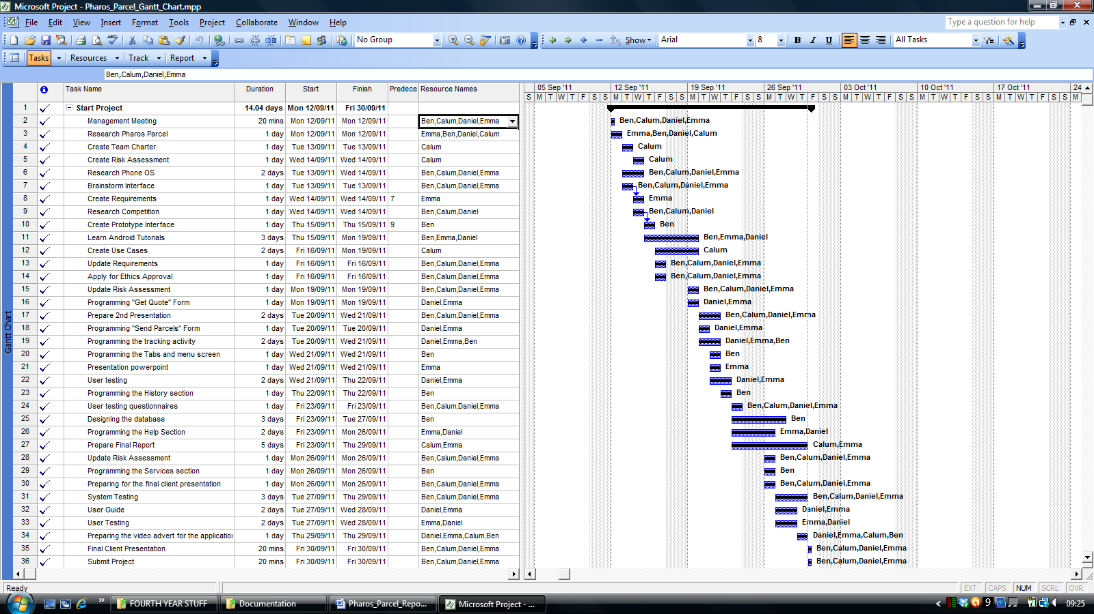

Bibliography

Sources Referenced

Anon. (2011) Wikipedia: Android (operating system) [online] Available at:
http://en.wikipedia.org/wiki/Android_(operating_system)
[Accessed 23rd September, 2011].

Johnson, D. (2011) SMS Marketing Blog: Smartphone Penetration [online] (Data supplied by Nielsen). Available at:
http://www.tatango.com/blog/smartphone-penetration-hits-forty-percent/
[Accessed 23rd September, 2011].

Anon. (2011) Wikipedia: Blackberry [online] Available at:
http://en.wikipedia.org/wiki/BlackBerry#Third-party_software
[Accessed 23rd September, 2011].

Anon. (2011) Pharos Parcel [online] Available at:
http://www.pharosparcel.com/
[Accessed 23rd September, 2011].

Anon. (2011) Android Developers [online] Available at:
http://developer.android.com/index.html
[Accessed 19th September, 2011]

Anon. (2011) Eclipse: The Eclipse Foundation Open Source Community [online] Available at:
http://www.eclipse.org/
[Accessed 19th September, 2011]

